Student’s name | …………………………………………………….…… | Grade | 4
Subject | Computer | Week No. | 9
Lesson Title | Presentation | Unit
Worksheet No. ( 9 )

Question A: Write the correct name of each part.

Slides Tab | Slides pane | Notes pane & view area

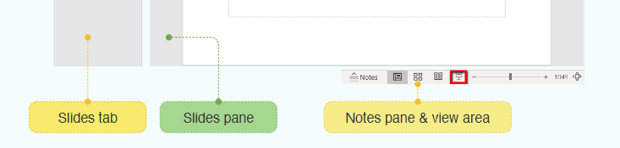
Good Luck

